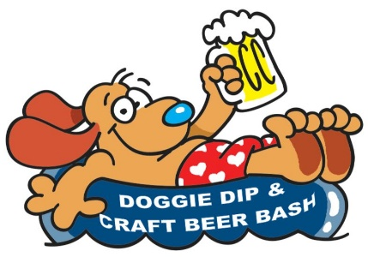
Centerville Disk Golf
Doubles Championship
Saturday, August 25, 2018
Morgan E. Cline City Park, Centerville, Iowa

Registration will begin at 10:30
Tee off at 11:00

Round 1: Best shot
Round 2: Best Score
Lunch served between rounds

Team Name _______________________________________________________________________
Player #1 Name ____________________________________________________________________
Email _____________________________________________________________________________
Mailing Address _______________________________________ City _________________________
Shirt Size (Circle One) S M L XL 2XL
Player #2 Name ____________________________________________________________________
Email _____________________________________________________________________________
Mailing Address _______________________________________ City _________________________
Shirt Size (Circle One) S M L XL 2XL
Team Contact Person ________________________________________________________________
Registration Fee:
Before August 24, 2018: $40/team includes two (2) t-shirts and two (2) lunch vouchers.
After August 24, 2018: $50/team includes two (2) t-shirts and two (2) lunch vouchers.
Payment will be due upon check-in. Preregistered teams will be charged the discounted rate.
Print, FILL OUT, then scan or “copy and paste” registration form and e-mail it to dcbozwell@gmail.com

Stay after golf for LIVE ENTERTAINMENT AND CRAFT BEER BASH

TRY OLD AND NEW CRAFT BEER FAVORITES!

