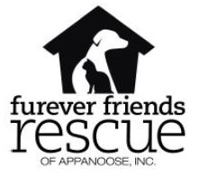
FUREVER FRIENDS ANIMAL SHELTER:
A SUMMER FIESTA FUNDRAISER WITH
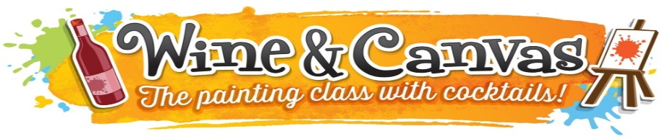
Food, Drinks and Prizes!

Awesome silent and live auction items!

Check the Furever Friends website and Facebook page for highlighted items.

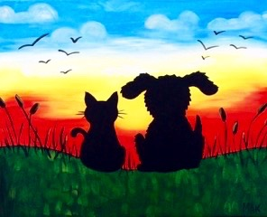

Your Painting: “Best Buds” – Give from the Heart with Art!
June 2nd, 2018 6:00-9:00 PM, $35
Majestic Theater Ballroom (100 N. 13th St. Centerville, IA)
(A portion of your registration fee will benefit
Sign up https://wineandcanvas.com/private-events-calendar-des-moines-ia.html
Show up Your paint supplies are waiting!
Paint! Our Artist will give you step-by-step instructions on painting the town RED!

Furever Friends Rescue)
For more information, visit www.FureverFriendsRescueofAppanoose.org
Or visit our Facebook page (FureverFriends8)
or contact www.wineandcanvas.com or call (515) 829-0661

